Parking spaces:
1 reserved (space #121)
2 temp visitor passes (short term less than 5 days per pass per month)

Keys:
1 garage clicker
1 pool fob
1 pool tag (pass to keep on hand while at pool)
2 house keys (front & garage door are the same)
1 mail key (mail box is on the west end of the street, middle set of boxes) #3

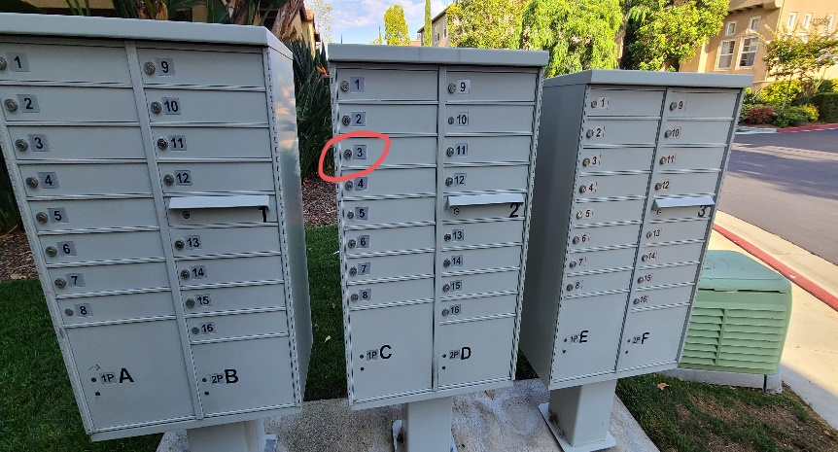

HOA:
SeaBreeze Management
$275/month

Mello Roos:
See tax roll

- Vinyl Flooring in 2016
- Closet with Built-ins
- Surround sound system
- Garage above head storage racks
- Water Heater in 2016
- Fridge in 2018
- Garage springs replaced in 2018
- Counters in kitchen/bath (brand new)
- Kitchen cabinets finished and painted (brand new)
- Dishwasher (brand new)
- BBQ & All appliances convey

